Functional Specification
High Level Functionalities
The Marshfield School must perform the following main functions:
Display historical content: The website displays four history pages. First one is an about page that gives an idea about the system. It also covers Chapel Green Board School, Thornton Lane Board School and Marshfield School. Each of these pages has some relevant text and Notable Dates.
Navigate between pages: The website has a navigation bar allowing users to move freely between all selections of application.
Open historical documents: The system must allow users to click on history pages to open original logbooks, admission registers, punishment books as PDFs included directly in the browser.
Search Staff: Users can search staff using specific criteria such as name or department.
Search Sources: Users can search historical sources and display the sources he has searched for.
Display Images: The website displays historical images related to the school’s history.
Use Case Diagram
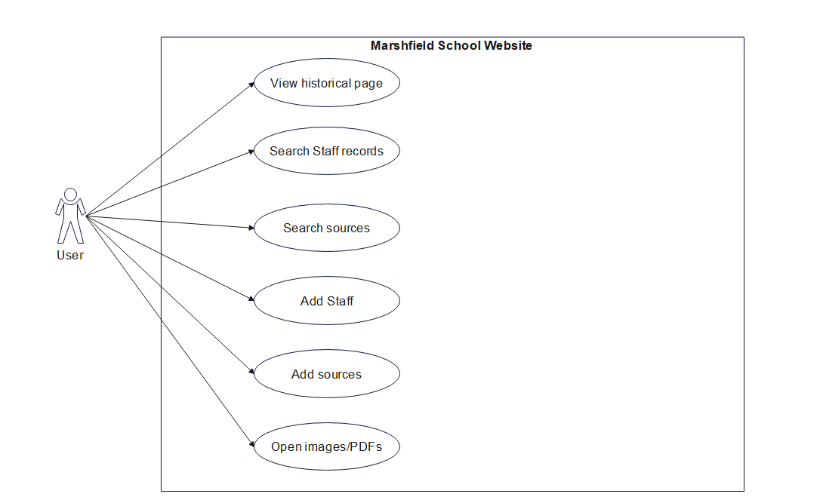

Description | Priority | Dependencies
Allowing users to navigate between different historical pages | High | Requires a navigation bar
Displaying historical images and data about different schools | High | Clicking on the school’s name in the navigation bar
Allowing users to search for staff members | High | Requires staff database
Allowing users to search for historical sources | High | Requires sources database
Displaying the result in a table format | Medium | Requires a UI design
Allowing users to add a new staff member | High | Requires a form and an adding button
Allowing users to add a new source | High | Requires a form and an adding button
Allowing users to view images/PDF documents | High | Images stored in a Folder  PDFs are required as well
Functional Requirements

Testing/Acceptance Criteria
Test Description | Expected Result
Opening the system | First page loads
User opens schools’ history pages | Content is displayed correctly
Page includes images | Images load correctly
User clicks a PDF document | PDF opens in brower
User searches for staff | Matching results appear
User searches for sources | Matching results appear
User adds a staff | Staff added correctly on the bottom of the list
User adds a source | Source added correctly on the bottom of the list

